# User’s Guide

* 1. Instructor Guide
     1. Taking Attendance Auto
        1. Login

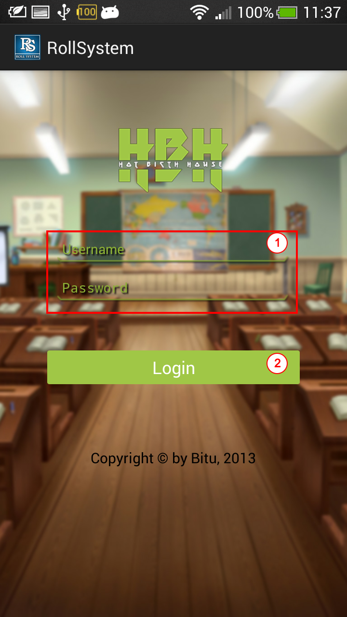

**Figure 1: Login Activity**

|  |  |
| --- | --- |
| **Step** | **Description** |
| 1 | Fill Username and Password |
| 2 | Click button Login |

* + - 1. View Roll Call list

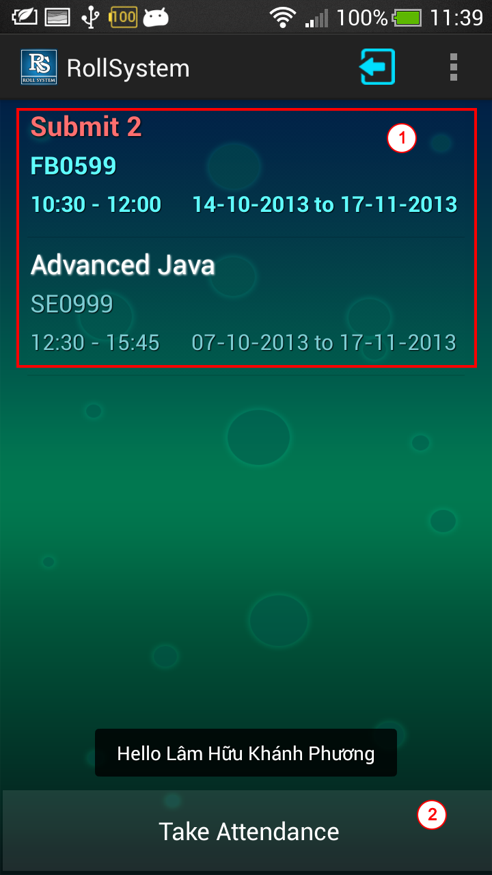

**Figure 2: Course Activity**

|  |  |
| --- | --- |
| **Step** | **Description** |
| 1 | View Roll Call list and make sure about the roll call that you want taking attendance |
| 2 | Click button Take Attendance |

* + - 1. Capture image

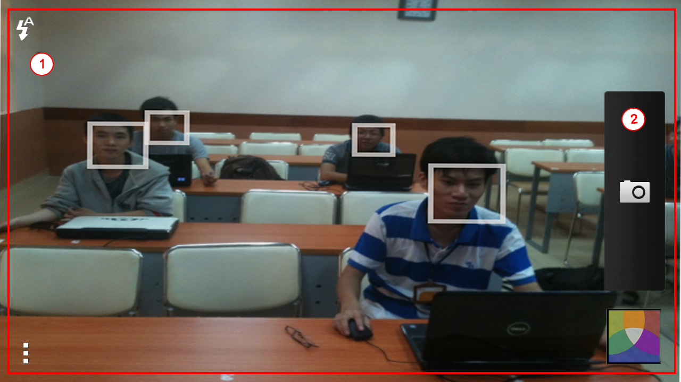

**Figure 3: Camera Activity**

|  |  |
| --- | --- |
| **Step** | **Description** |
| 1 | View camera screen and choose the best position and angle |
| 2 | Click button to capture image |

* + - 1. Taking Attendance Auto

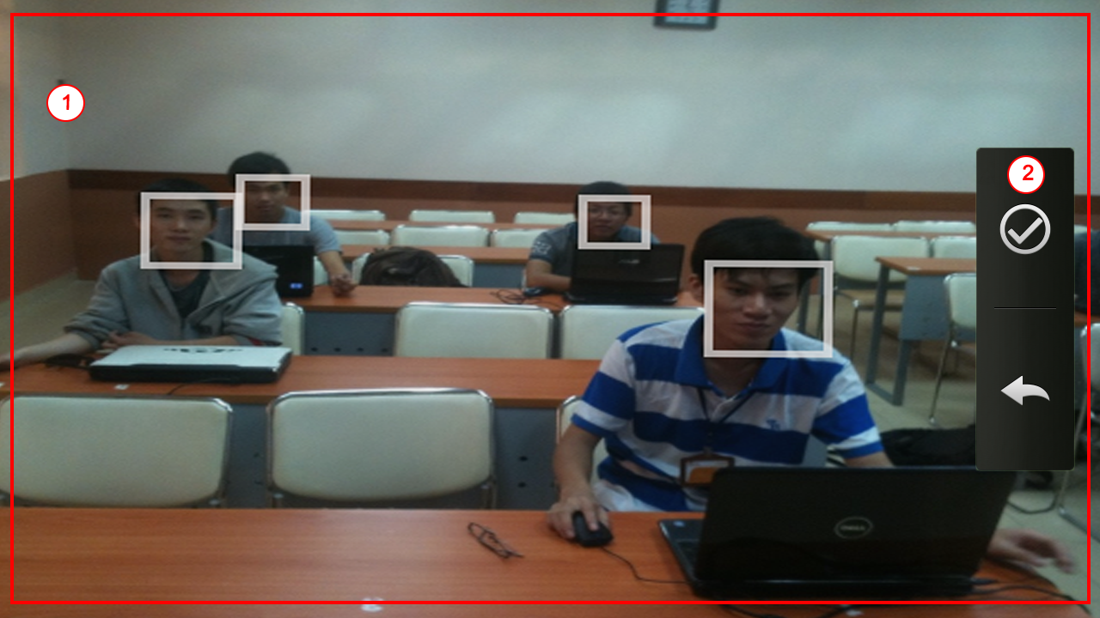

**Figure 4: Camera Activity**

|  |  |
| --- | --- |
| **Step** | **Description** |
| 1 | View your capture image |
| 2 | Click button to taking attendance auto |

* + 1. Taking attendance Manual
       1. Login



**Figure 5: Login Activity**

|  |  |
| --- | --- |
| **Step** | **Description** |
| 1 | Fill Username and Password |
| 2 | Click button Login |

* + - 1. View and choose one Roll Call

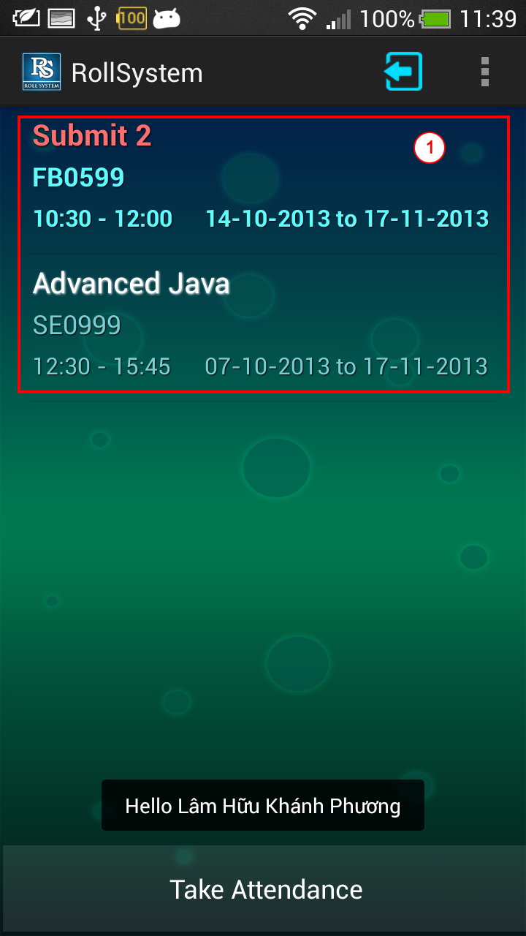

**Figure 6: Course Activity**

|  |  |
| --- | --- |
| **Step** | **Description** |
| 1 | View Roll Call list and choose the roll call that you want to taking attendance manual |

* + - 1. View Roll Call info and choose one Roll Call Log

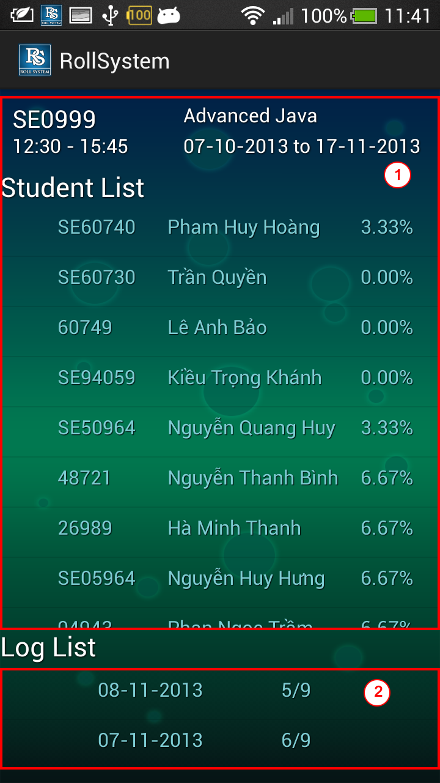

**Figure 7: Roll Call Activity**

|  |  |
| --- | --- |
| **Step** | **Description** |
| 1 | View Roll Call info (class, subject, date, time, student list and log list) |
| 2 | Click one log you want to taking attendance manual |

* + - 1. Taking Attendance Manual

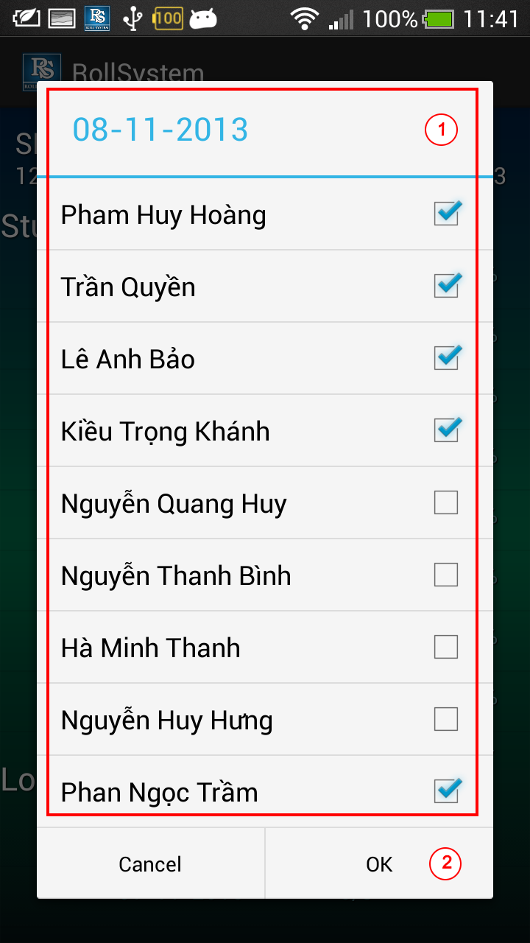

**Figure 8: Roll Call Activity**

|  |  |
| --- | --- |
| **Step** | **Description** |
| 1 | View student list in roll call and check or uncheck any student. |
| 2 | Click button OK to taking attendance manual |